# Select the right .melt() arguments

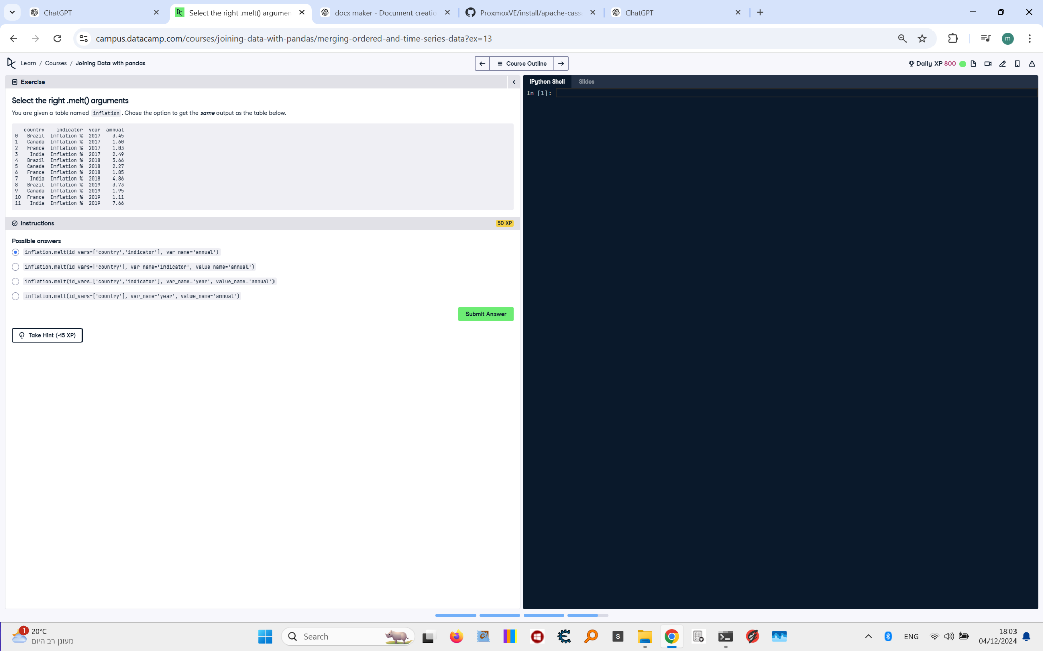

## Question:

You are given a table named inflation. Choose the option to get the same output as the table below.

## Answer:

### Correct Answer:  
```  
inflation.melt(id_vars=['country', 'indicator'], var_name='year', value_name='annual')  
```  
  
### Explanation:  
1. `id_vars=['country', 'indicator']` specifies the columns to keep as identifiers.  
2. `var_name='year'` renames the variable column (originally columns representing years) to 'year'.  
3. `value_name='annual'` renames the values column to 'annual', representing annual inflation values.